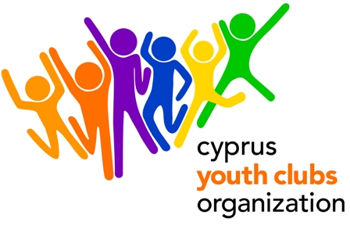
Volunteering without frontiers
A European Youth Exchange with the support of the EU Youth in Action Programme

PROJECT OUTLINE
- Project title: Volunteering without frontiers
- Organization: Youth Centre of Palodia.
- Main theme for the project: Volunteering, Intercultural Learning, Youth Participation
- Number of participants: We encourage organizations to participate with 6 people each and 1 leader (gender balanced group).
- Age range for participants: 18- 25. 20% of participants will be 25-30 (people with fewer opportunities).
No age limit for the Leaders
- Project type: Youth in Action (Action 1 – Youth for Europe/ Sub-Action 1.1 Youth Exchanges)
- Organization’s Country: Cyprus
- Place: Cyprus Limassol
- The project starts: 21 April 2011 (arrival day)
- The project ends: 28^{t} April 2011 (departure day)
- Duration: 6 days
- Group age (average): none
- Contact person: Yiannis Georgiou
- E-mail: info@knpalodias.com
- Tel.: +357 99058112
- Fax: +357 25 775800
- Summary of the project:
Volunteering is a significant feature of civic participation in any democratic society. Young people invest time and skills to address collective and public problems and to find solutions without expecting any payment. Although in many traditional social systems volunteering is partly undertaken by the neighbourhood and family, modernisation and individualisation has seriously affected the attitudes and values of altruistic behavior. Volunteering is a key principle of youth participation, civil society building. Our project aims at promoting political, social and economic participation of youth through volunteering. While bringing together people from different countries we will ensure that the interaction between people from different cultural backgrounds can explore perceptions, attitudes and methods related to volunteering. At the same time, they can identify common values and create strategies to promote volunteerism in their organizations and their communities in general. We invite youth workers, youth leaders and volunteers to participate.
- Financial aspects: Participants will be reimbursed for the 70% of the travel cost on display of their boarding passes. Reimbursement of travel costs will only be done upon full attendance in the activity and presentation of the original tickets with boarding passes and receipt/invoices. Food and accommodation is paid. Participants will be required to pay a participation fee of €30.
- Safety & Insurance: We will require copies of the travel insurances before travelling to Cyprus.
- How to participate: Send us a short description of your organization and the link to your website (if available). After you fill in the Part 3 (make sure it is the 2010 version), send the scanned version to Yianni Georgiou (info@knpalodias.com) and mail the original to:

Yiannis Georgiou
Youth Centre Palodias T.K 4549 Limassol, CYPRUS

